**DAILY ONLINE ACTIVITIES SUMMARY**

|  |  |  |  |  |  |  |  |
| --- | --- | --- | --- | --- | --- | --- | --- |
| **Date:** | **19/05/20** | | | | **Name:** | **JYOTHI LAKSHMI** | |
| **Sem & Sec** | **8th sem, B sec** | | | | **USN:** | **4AL16CS129** | |
| **Online Test Summary** | | | | | | | |
| **Subject** | | **BDA** | | | | | |
| **Max. Marks** | | **30** | | **Score** | | **17** | |
| **Certification Course Summary** | | | | | | | |
| **Course** | **Introduction to Ethical Hacking** | | | | | | |
| **Certificate Provider** | | | **Great Learning** | **Duration** | | | **35 mins** |
| **Coding Challenges** | | | | | | | |
| **Problem Statement: 1) To find out the shortest palindrome 2) To identify is given list is palindrome or not using stack** | | | | | | | |
| **Status: Completed** | | | | | | | |
| **Uploaded the report in Github** | | | | **Yes** | | | |
| **If yes Repository name** | | | |  | | | |
| **Uploaded the report in slack** | | | | **Yes** | | | |

Online Test Details:

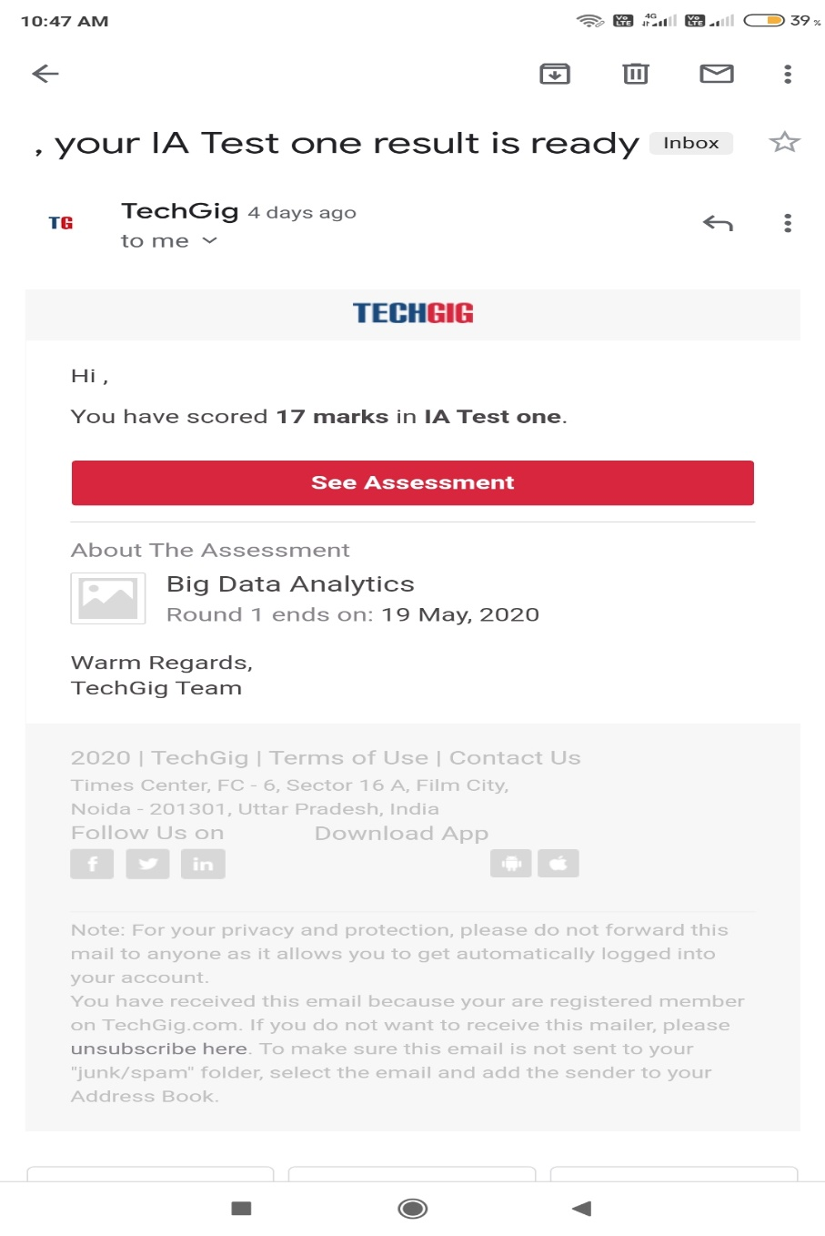

The test was on the subject Big Data Analytics on Module 1.

Certification Course Details:

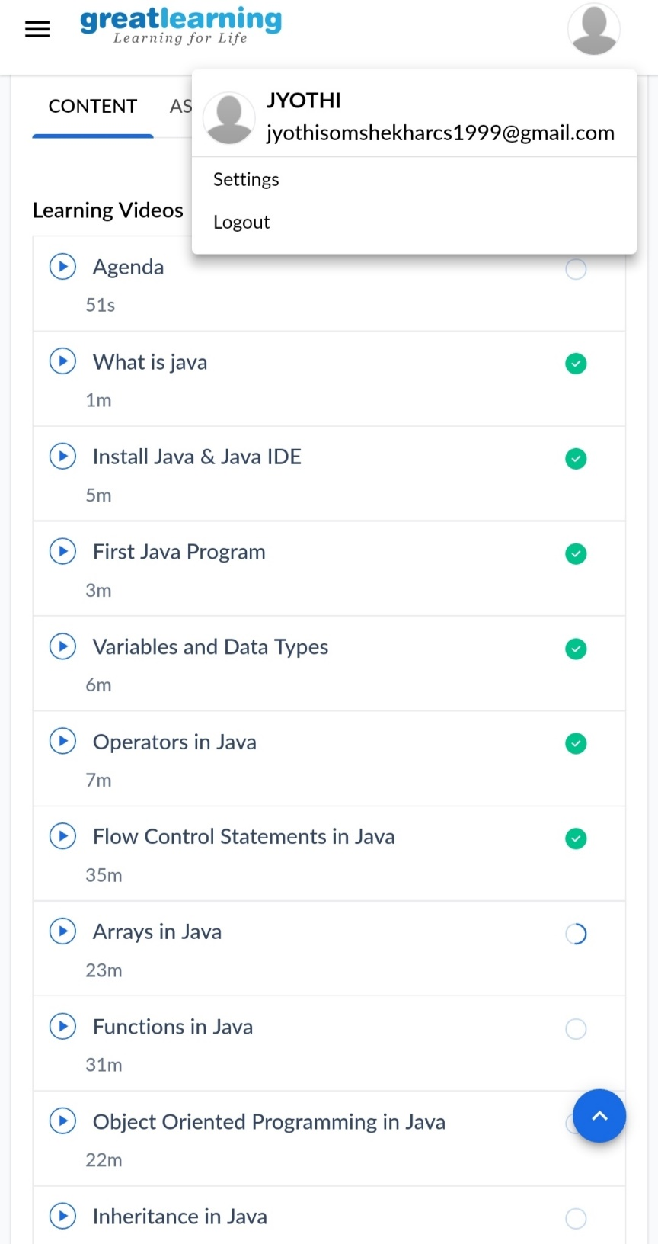

Coding Challenges Details:

1) We have a Letter or a word then we need add some letters to it and need to find out shortest palindrome

For example we take "S": S will be the shortest palindrome string.

If we take "xyz": zyxyz will be the shortest palindrome string

So we need to add some characters to the given string or character and find out what will be the shortest palindrome string by using simple java program.

package shortestpalindromeexample.java;

import java.util.Scanner;

public class ShortestPalindromeDemo {

public static String shortestPalindrome(String str) {

int x=0;

int y=str.length()-1;

while(y>=0){

if(str.charAt(x)==str.charAt(y)){

x++;

}

y--;

}

if(x==str.length())

return str;

String suffix = str.substring(x);

String prefix = new StringBuilder(suffix).reverse().toString();

String mid = shortestPalindrome(str.substring(0, x));

return prefix+mid+suffix;

}

public static void main(String[] args) {

Scanner in = new Scanner(System.in);

System.out.println("Enter a String to find out shortest palindrome");

String str=in.nextLine();

System.out.println("Shortest palindrome of "+str+" is "+shortestPalindrome(str));

}

}

2) Write a simple code to identify given linked list is palindrome or not by using stack.

First take a Stack. Traverse through each node of the linked list and push each node value to Stack.

Once the traversal & copying is done, iterate through linked list from head node again.

In each iteration, pop one stack element and compare with node value in respective iteration. It is expected to match stack popped value with node value.

In case of all matches, its a palindrome. Any one element mismatch makes it not a palindrome.

import java.util.Stack;

class Node {

int data;

Node next;

Node(int i)

{

this.data = i;

this.next = null;

}

};

class Main

{

public static boolean isPalindrome(Node head)

{

Stack s = new Stack<>();

Node node = head; // push

while (node != null) {

s.push(node.data);

node = node.next;

}

// traverse

node = head;

while (node != null)

{

int top = s.pop(); //pop

if (top != node.data) {

return false;

}

node = node.next;

}

return true;

}

public static void main(String[] args)

{

Node head = new Node(1);

head.next = new Node(2);

head.next.next = new Node(3);

head.next.next.next = new Node(2);

head.next.next.next.next = new Node(1);

if (isPalindrome(head)) {

System.out.print("Linked List is a palindrome.");

} else {

System.out.print("Linked List is not a palindrome.");

}

}

}